Get more information:  - By posting (where exactly?)  - At our customer information / reception / cashier on the ground floor  - On the Internet at… | Name and contact details of the person responsible/controller and, where applicable, the representative:  Contact details of the data protection officer (if available):  Purposes and legal basis of data processing:  Legitimate interests being pursued:  Storage duration or criteria for determining the duration:  Recipients or categories of recipients of the personal data, if any:

Rights of the data subjects
As a data subject you have the right,
- to obtain from the controller confirmation as to whether or not personal data that concerns you is being processed, and, where that is the case, access to the personal data according to Article 15 GDPR.
- to obtain from the controller without undue delay the rectification of inaccurate personal data that concerns you (Article 16 GDPR).

Sample template: On-the-spot notice
Example of an On-the-spot notice according to Article 13 of the General Data Protection Regulation for video surveillance.
Note: Information should be provided free of charge in a clear, transparent, understandable and easily accessible form in a clear and simple language. It can be provided in combination with standardized pictograms (see Article 12 GDPR). In order to achieve readability, the size of the printout should be at least DIN A4.
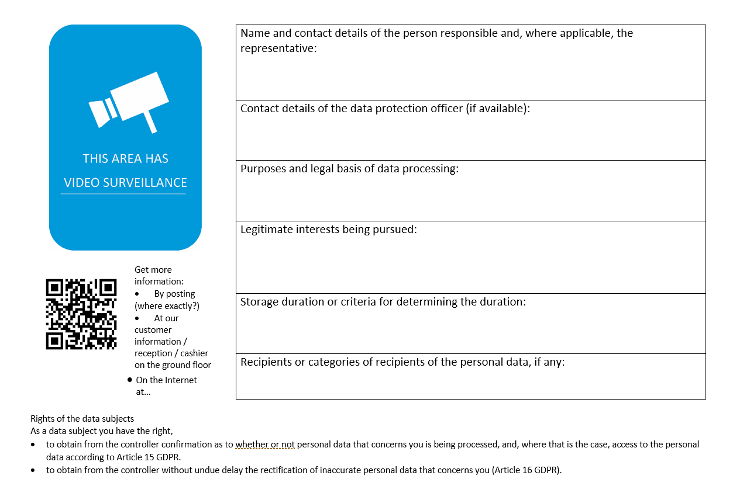

Instructions
[Insert your video surveillance pictogram: you may consider, for example, the ISO pictogram or the pictogram customarily used where you are located.]
- Name and contact details of the person responsible
- Contact details of the data protection officer (if available)
- Purposes and legal basis of data processing
- Legitimate interests being pursued
- Storage duration or criteria for determining the duration
- Recipients or categories of recipients of the personal data, if any:
[where applicable, the fact that the controller intends to transfer personal data to a third country or international organization and the existence or absence of an adequacy decision by the Commission, or reference to the appropriate or suitable safeguards.]
For further information, please consult www.domainnameofyourorganization/cctv or contact the Agency's security unit at [telephone number and email address]. Provide information as described in References to the rights of those affected, in the following.
[Include multiple language versions when applicable.]

References to the rights of those affected (to be posted online)
The data subject has the right to request confirmation from the controller as to whether personal data concerning him or her is being processed; if that is the case, the data subject has the right to information of that personal data and of the information detailed in Article 15 GDPR.
The data subject has the right to request the controller to rectify inaccurate personal data concerning him or her immediately and, if necessary, to complete incomplete personal data (Article 16 GDPR).
The data subject has the right to require the controller to delete personal data concerning him or her without delay, provided that one of the reasons set out in Article 17 GDPR is specific, for example if the data is no longer needed for the purposes pursued (right to erasure).
The data subject has the right to require the controller to restrict the processing if one of the conditions set out in Article 18 GDPR is met, for example if the data subject objects to the processing for the duration of the review by the controller.
The data subject has the right, at any time, to object to the processing of personal data for reasons arising from his or her particular situation. The controller will no longer process the personal data unless he can prove compelling legitimate grounds for the processing that outweigh the interests, rights and freedoms of the data subject, or the processing serves the purpose of the enforcement, exercise or defense of legal claims (Article 21 GDPR).
Without prejudice to any other administrative or judicial remedy, any data subject shall have the right to lodge a complaint with a supervisory authority if the data subject considers that the processing of personal data concerning them is contrary to the GDPR (Article 77 GDPR). The data subject may assert that right with a supervisory authority in the Member State of his or her residence, place of work, or the place of alleged infringement. In (state), the responsible supervisory authority is: [supervisory authority]

